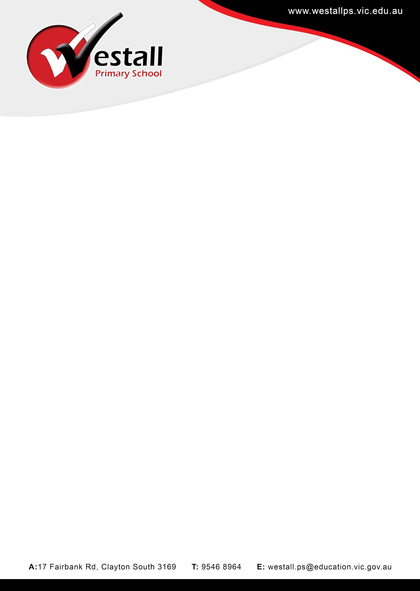

Hire Rates for School Facilities in 2026

Per Room | Bond | Hour rate | Day rate morning/afterno on or evening* | Long term* - Day rate morning/afte rnoon or evening*
Classroom | $200 | $33 p/h | $110 | $55
Hall | $500 | $55 p/h | $220 | $150
Hall (# Commercial Rate, includes cleaning) | $500 | $70 p/h | - | -
Outdoor Courts or Oval | $200 | $55 p/h | $220 | $150
Cancellation Fee | > 1 Month - no fee  <1 Month - 50%

- All Rates GST Exclusive
- All rates include utilities and use of adjacent toilets and the school car park.
- All long term hires to be paid a term in advance
- Hirer must organise for or pay for cleaning of toilets and rented area if they require cleaning. The school will bill for any areas that need to be cleaned at the rate charged by the school clearers. (approx $130 for hall and toilets)
- Hirer must pay for any security call outs
- To enable access to other hirers, day rates are generally for a Morning (6:00 am - 12:00pm), Afternoon 12:00pm - 6:00pm) Evening ( 6:00-12pm), this can be negotiated depending on availability

Bond forfeit - to value required for: rooms not clean, keys not returned, any damage is evident to flooring, furniture or fittings.
*Long term rate - 1 Year or more booked and paid 1 term in advance
# Commercial rate - for association level sports or paid activities that includes high traffic

